

MSCI 431

**Markov Momentum**

**Prepared by:**

Vyomesh Iyengar (20884898)

Inesh Jacob (20898664)

André Larocque (20880058)

Rodrigo Tiscareno (20873638)

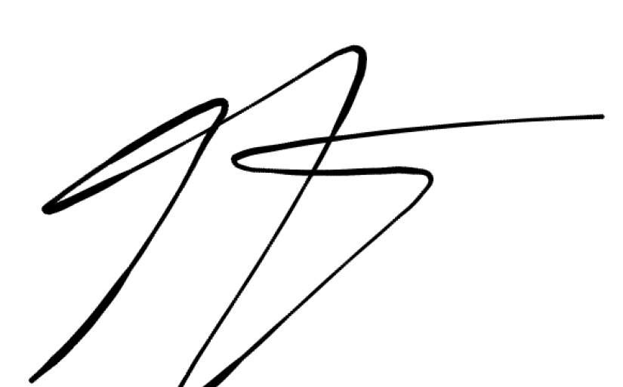

**Prepared for:**

Professor Jim Bookbinder & TAs

**Table of Contents**

**Introduction 1**

**Research Article Analysis 2**

Coach Markov Pulls Goalie Poisson 2

Summary 2

Model Testing 5

Analysis 6

Pulling the Goalie Revisited 7

Summary 7

Model Testing 9

Analysis 9

Pulling the Goalie: Hockey and Investment Implications 10

Summary 10

Analysis 11

**Markov Momentum 12**

Introduction 12

Derivation 12

Important Assumptions 13

Testing 14

Comparisons 17

Bibliography 18

# Introduction

Pulling the goalie in hockey can provide a significant offensive advantage to a team when they are behind in the scoreboard and chasing that crucial goal to tie the game. While bolstering their likelihood of scoring a goal, a team also compromises their defensive ability, essentially pulling their last-line of defense for an extra offensive player. This overload of offensive players can resemble a power play, where a team has a numerical superiority and dominates offensive play through the duration of the penalty. However, the risk of leaving an empty net can allow opposing teams to increase their lead with ease due to the lack of defensive-players on the rink. Therefore, a team has to pull the goalie at the right *time* to balance the probability of scoring an equalizing goal and the risk of conceding and potentially losing the game definitively.

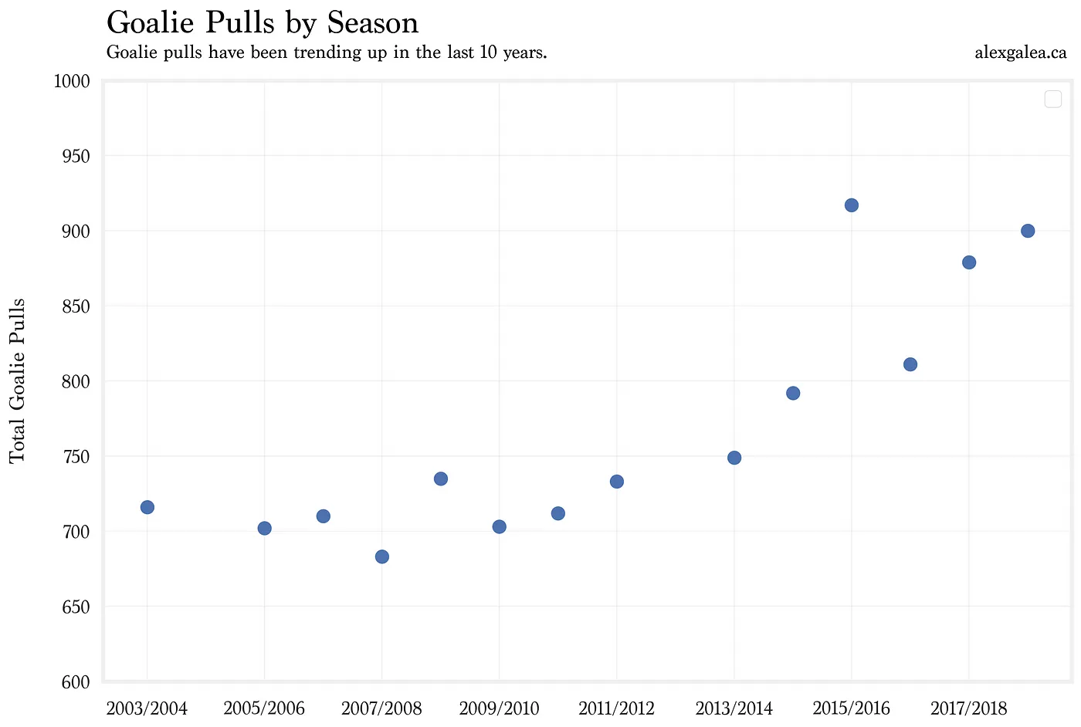

**Figure 1:** The growing trend in pulling the goalie by season generated by Alex Gales.

As represented by *Figure 1,* there is a growing trend in teams pulling their goalie across the 2003 and 2018 league seasons. As a result, there have been numerous studies and research related to stochastic processes to determine the optimal time to pull the goalie. While some focus on the positioning of the puck, the poisson rates associated with a shot or a goal, or the general rates at which either team scores a goal, most models suggest an average time ranging between two to six minutes remaining in the game. However, each model and representation of a hockey game displays a flaw within their assumptions, modeling, or consideration of in-game statistics which will be carefully explored.

This project report aims to dispel the flaws and make improvements on existing models by leveraging empirical data and our knowledge of stochastic modeling. Previously-written articles will be summarized, analyzed, and evaluated for areas of improvement. In addition, an improved model based on game momentum will be explored and tested as an improvement to the previously-researched articles. This model will find the optimal *time* in a game to pull the goalie when the current team is down a goal to the opposing team. Finally, a comparison between models and justification for the new approach will be made to determine the optimal model for determining the time to pull the goalie and take-on an offensive approach.

# Research Article Analysis

## Coach Markov Pulls Goalie Poisson

### Summary

The *Coach Markov Pulls Goalie Poisson*, written by Zia Zaman and published in September 12, 2020, approaches stochastic modeling of pulling the goalie with *positional-play* considerations. As depicted in *Figure 2,* Professor Zaman defined a Markov process where the states in the Markov chain are dependent on the current positional location of the puck. Each transient state, “Shot A”, “Shot B”, “Neutral”, “Zone A,” and “Zone B” describe the location of the puck with regards to Team B being the team that pulls the goalie. In addition, the absorbing states “Goal A” and “Goal B” conclude the process depending on what the play results in. Professor Zaman argues that a puck can either slide into its previous location or enter an area closer to the net, in which case the probability of a goal will increase.

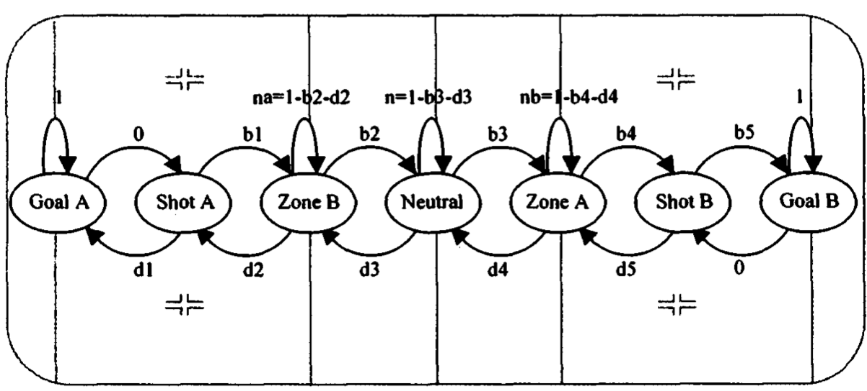

**Figure 2:** The Markov Chain representation in the *Coach Markov Pulls Goalie Poisson* study.

In this model, there are two distinct processes described depending on whether the teams are playing with an equal number of players or with Team B having numerical superiority. The *even* *strength* Markov chain represents the same states as in *Figure 2*, however, corresponding probabilities between states are tuned to reflect the even number of players on the rink. The model is adjusted for when the number of players on the rink is equal and a new *empty net* Markov Chain is derived in which the probabilities of either team scoring are adjusted and increased to represent the heightened probability of scoring.

Converting both the *even strength* and *empty net* Markov chains into their transitive matrix, the probability of transition from state *i* to state *j* given *t* amount of seconds is calculated by raising either matrix to the tth power, in which the probability will be given by the value in the [ith, jth] element in the matrix. As shown in *Figure 3*, the optimal time to pull the goalie becomes the intersection of the probabilities as a function of time, *t.* This represents the point in time at which the probability of Team B scoring in the scenario of even strength and having an empty net are equal.

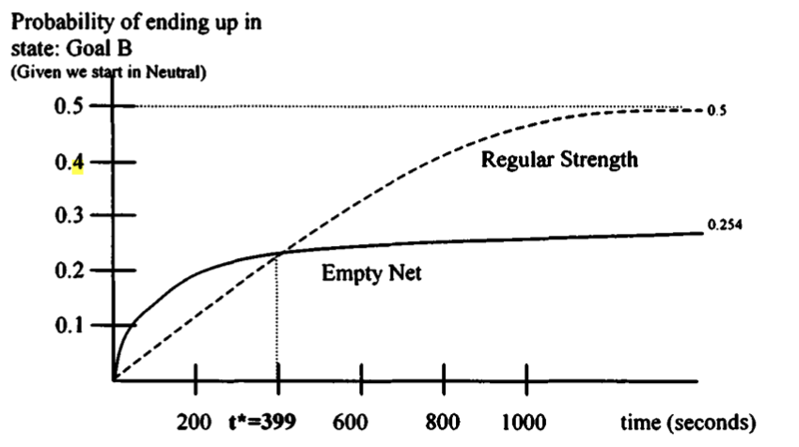

**Figure 3:** The intersection represents the point at which both probabilities for going from a neutral state to Team B scoring meet.

This methodology holds true for any state *i* and its transition to another state *j*.

### 

### Model Testing

The article claims that the optimal time remaining to pull the goalie if Team B is losing by one goal and the puck’s initial position is from the neutral state is 399 seconds, or approximately six minutes and forty seconds.

However, based on data from NHL seasons 2003-2019 as compiled by *Chord Analytics* and refined to our use-case in a Jupyter Notebook, the average time remaining to when a team pulled their goalie is 172.63 seconds from 1611 samples of when teams have pulled their goalie and scored a goal. There is over a 200 second discrepancy between their theoretical value and the empirical value gathered over 16 seasons which warrants an improved model. There is a limitation with this comparison. Recall that the model predicts the optimal time remaining to pull the goalie based on the assumption that the puck starts in the neutral zone. The empirical data does not specify when the team pulls the goalie and therefore where the puck is on the field, so it may well be that the empirical data reflects a state where the puck’s location is closer to the goal.

We tested the model with another scenario: Team A leading the game by one-goal, and scoring a goal on Team B’s empty net from the puck initially starting in the neutral zone. We leveraged the Jupyter Notebook to compute the probability of the Markov Chain for both the even strength and empty net models to then find their intersection among t, the time remaining. *Figure 4* indicates that both Markov Chains intersect where the time is at 469 seconds remaining compared to the 122.7 average seconds as acquired from 3736 records and the empirical data inside the Jupyter Notebook. With a discrepancy of over 300 seconds, the model must be under-estimating the probabilities of Team A scoring against an empty-net.

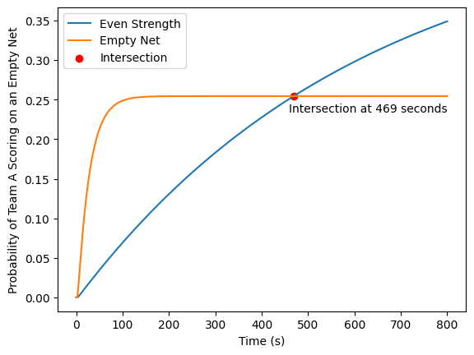

**Figure 4:** The intersection represents the point at which both probabilities for going from a neutral state to Team A scoring meet.

### 

### Analysis

Given that the Markov model is based on positional play, a major flaw of the proposed model is the assumption that, at five players each, the teams are evenly matched. The probabilities for the puck transferring from each state are symmetrical in the *even* *strengt*h model and constant in the *empty net* model. This assumption is flawed. The level of players in a team differs per game and directly impacts where the play will be centered around for the majority of the game. This may cause the probabilities of each transition to differ on a team-basis or whichever team is dominating the game. An improvement can be made for this model if the probabilities for entering each zone were adjusted for the type of teams playing in a given game. Collecting such custom data may seem infeasible but an in-game momentum analysis, studying teams’ run-of-form before a game, or adjusting the probabilities of each zone according to perceived player ability may be more feasible and lead to accurate probabilities and weights for each transition of zone.

Similarly, a flaw within the *empty net* Markov chain is the fact that the probability of entering an attacking zone from a neutral position are equal for both teams. This is addressed by Professor Zaman, as they admit “ it is certainly plausible that Team B,with the extra attacker, has an advantage in the neutral zone so that [entering Zone A is more probable than entering Zone B].” However, this flaw is not addressed through the weighting of the Markov Chain.

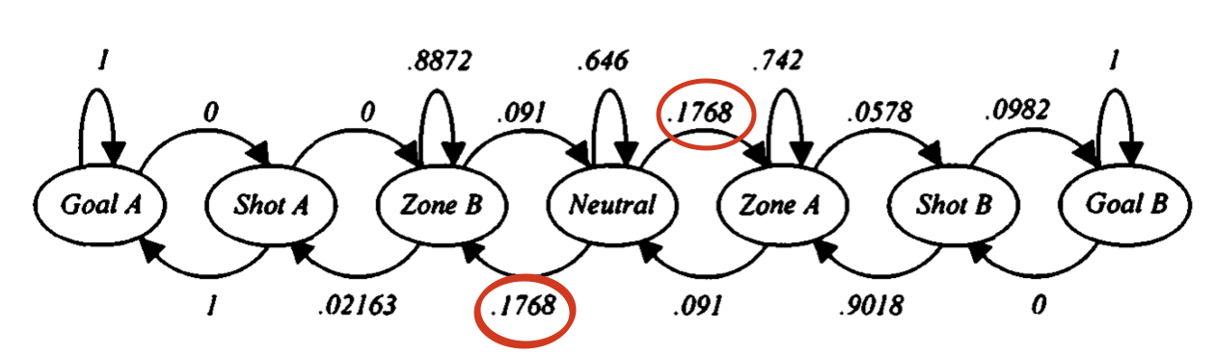

**Figure 5:** The probabilities of entering each zone from the neutral zone are equal in the *empty net* scenario.

As depicted in *Figure 5*, the probability of entering either zone with an *empty net* assumption is equal for both teams at 0.1768, despite Team B holding a numerical superiority. In addition, the probability of entering the neutral zone from each zone is equal at 0.91 as well. While there exists a numerical superiority, there are more barriers to entry for the defending team for each state and, likewise, more facilitations for the attacking team to enter the state. Therefore, the probabilities of entering or leaving the neutral zones should reflect the imbalance caused by the numerical imbalance.

## Pulling the Goalie Revisited

### Summary

The article *Misapplications Reviews: Pulling the Goalie Revisited*, written by Donald G Morrison and Rita D Wheat focuses on the question: does the favorable joint event (a team scoring a goal, and that team being your team) have a higher probability of occurring with or without your goalie in the game? The article discusses the flaws in analyses from Morrisons original study from 1976, and both explains the original model as well as the changes that should be made to the model based on these flaws. The article begins by assuming that λB > λA > λ where λA is Team A’s scoring rate when its goalie is pulled, λB is Team B’s scoring rate when Team A’s goalie is pulled, and λ is both team’s scoring rate when both goalies are present. It also makes the assumption that scoring processes for Team A is independent of the scoring process of Team B. The article focuses on creating a model which obtains a tie by having the team which is down by one point score a goal.

The first model discussed looks to solve for *t\**, which is the optimal time *t* at which the goalie is to be pulled. This is solved by equating the probability of obtaining a tie when your team is down by one goal with *t* minutes remaining in the game and you pull your goal with the same probability except you chose not to pull your goalie. However this is not an accurate representation of the problem at hand because comparing this model is comparing pulling the goalie at time *t* with not pulling the goalie at time *t*, which would simply never allow the goalie to be pulled.

The second model looks to solve what the authors believe to be the true problem at hand: with *T* minutes left in the game and Team A down by one goal, what is the Poisson probability of a tie being achieved by the end of the game given *t* as the pull time. This led to a Poisson equation being create which equated the probability that a goal is scored in the time interval (T, t) and it was yours plus no goal is scored in (T, t) but a goal was scored in (t, 0) and it was yours to be the probability that a tie is achieved. *Figure 6* shows the equation in Poisson probability form, with the same variables used as above.

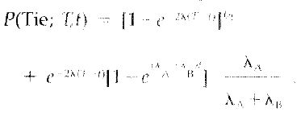

**Figure 6:** Poisson probability equation for a tie occurring

Maximizing this equation, provides the *t\** value at which the coach should pull the goalie, as shown in *Figure 7*.

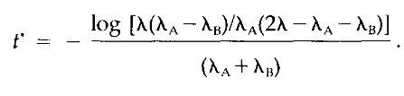

**Figure 7:** Maximizing of *t* value using log method

The authors mention that a very important aspect of the final *t\** value being calculated is the relationship between the λB, λA, and λ values. If the λB value is greater than λA by a factor of 10, the resulting *t\** value is double than if the λB value is greater than λA by a factor of 20. Though the relationship is not linear, there is a strong correlation with regards to the final *t\** value.

### Model Testing

Using the data from the 1979-1980 NHL hockey season, the article conducts an test of the equation in order to calculate a *t\** value. During this specific season, the goalie was pulled 387 times. Based on this data, the values for the variables were λB = 0.47, λA = 0.16, λ = 0.06, giving an optimal time to pull the goal of 2.34 minutes. These values were calculated by estimating using the method of maximum likelihood on the goals-per-minute scoring rates. λB is equal to the ratio of the number of times an extra man goal is scored during the season to the number of minutes during the season that the goalie is pulled. λA is equal to the ratio of the number of times during the season that an empty net goal is scored to the total number of minutes during the season that the goalie is pulled.

### Analysis

A key flaw with the model presented in the article is that the Poisson process does not account for the current state of the game, and assumes that goals can be scored with equal probability at any point in time, changing only if the goalie is removed. This is not true as the probability of a goal entering the net is highly dependent on the players on the ice, performance throughout the game, and where the puck is located during the game. In addition, the model does not take into account cases where Team A is down by more than one goal, causing it to not be scalable to other use cases. The model also assumes that all the players are on the ice during the time that the goalie is pulled, and does not account for the case where there is a penalty on either side. The data used for the testing of the model is very limited, only spanning one season, this means that the true time at which the goalie should be moved is highly susceptible to change given more widely spanning, and time-relevant data.

In order to improve this model, the Poisson probability should consider other states that the game could be at and how it would change the probability of Team A winning at a specific point in time. Instead of setting the λ values to be consistent throughout the game, the probability should also be set to change based on the current performance and how that could change the outcome. By making it more relational to the specificities of the game, the model can be more accurate and helpful in predicting the decisions for coaches.

## Pulling the Goalie: Hockey and Investment Implications

### Summary

The Pulling the Goalie: Hockey and Investment Implications by Clifford Asness and Aaron Brown, was drafted on October 1, 2018. The model detailed follows a poisson process with 5 parameters considered in total. The fundamental premise of the report is to suggest that pulling the goalie should be done much earlier, optimally with 6 minutes and 10 seconds remaining if the team is down by one goal. The paper tends to focus on a longer term average rather than a game by game adjustment.

The parameters that the model is based on includes the following probabilities: scoring goals with a goalie in place, the goalie is pulled for an extra attacker and the opposing team pulling the goalie but the current team has not. In addition to these, there are two other parameters which are the goal differential and the time remaining in the game.

The probabilities are calculated using data from the 2015-2016 NHL season by taking the number of even strength goals scored, 4947, and dividing it by the number of 10 second intervals played, 126 425. This provides a poisson rate of 0.0065 goals per 10 second interval. Using a similar process the poisson rate for the team with the 6th attacker is 0.0197 and 0.043 for the team that keeps the goalie in place. Based on these probabilities These probabilities are then used to formulate the expected point function, which takes the score differential and time remaining as its parameters. One crucial assumption that is made is that a tie at the end of regulation is worth 1.5 standing points. *Figure 8* is the expected point function of never pulling the goalie which utilizes the probability calculated for even strength scoring. *Figure 9* is the expected point function for pulling the goalie now and then acting optimally for the remainder of the game. It also takes into consideration not pulling now and then acting optimally thereafter. It utilizes the probabilities of neither team scoring and the calculated poisson rate of either team scoring when the current team has pulled the goalie. *Figure 10* shows that the optimal time to pull the goalie when the team is down by one goal comes at 6 minutes and 10 seconds remaining in the game. If the score differential was greater, the time would also proportionally be revised upwards.

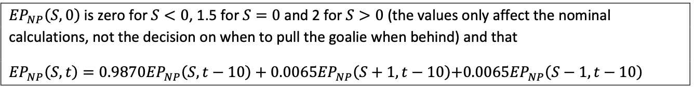

**Figure 8:** Formulation of the expected point function for never pulling the goalie.

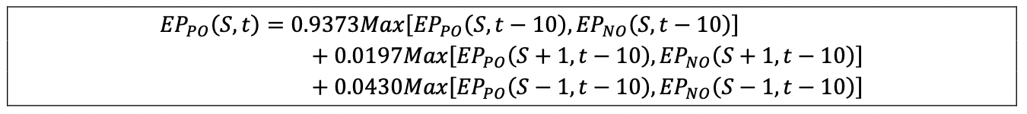

**Figure 9:** Formulation of the expected point function for optimally pulling the goalie.

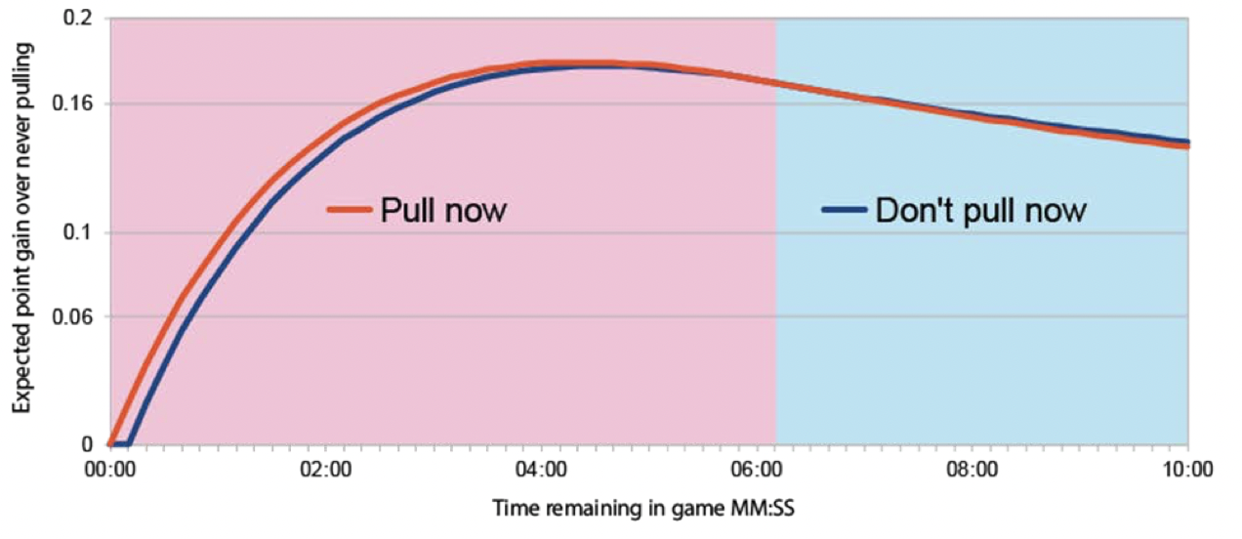

**Figure 10:** The intersection represents the optimal time to pull the goalie when the score differential is 1.

### Analysis

As stated in the article, the analysis is limited in scope due to some parameters not being considered. The ones given as examples for parameters that are included in other studies are which team is better, home ice advantage and the current penalty situation. By factoring in these parameters the model would better reflect individual games and be tailored to a team’s needs.

A potential flaw of the paper is that it may lack thorough reasoning to arrive at the optimal time. By using the number of goals scored in a single season and not accounting for anomalies, such as high scoring goals vs the most common scores. As it is only a single season worth of data, the outliers will have a higher impact on the probability of not pulling the goalie and scoring a goal. Depending on the season the model could be overestimating the probability of scoring a goal by a considerable amount. This would change the intersection point of the two expected point functions shown on *Figure 10*. Moreover, an assumption that is made in the paper is that a tie is worth 1.5 points. By doing so, the researchers have assumed that a team that ties is more likely to win then to lose. In hockey if you win you get 2 points and if you lose you get 0 points. If a team was to tie at the end of overtime, each team would get 1 point. Instead the assumption should be that each of these three outcomes are equally likely and thus the point value assigned for a tie should be 1.

# Markov Momentum

## Introduction

In the same way that the models explored in the *Coach Markov Pulls Goalie Poisson* study utilize positional play in their states, the *Markov Momentum* model is based on team momentum and authority on the game. Inside the model, there are two processes, one accounting for the even-strength scenario and another for the *empty net* scenario. *Figures 11 and 12\** outline the proposed models for the *even strength* and *empty net* scenarios respectively. These representations are with the assumption that Team A is the defending team and Team B is the offensive, pulled-goalie team.

|  |  |
| --- | --- |
| **Figure 11:** The transition matrix for the *even* *strength* scenario. | **Figure 12:** The transition matrix for the *empty net* scenario. |

## Derivation

The Markov Momentum model utilizes the momentum of the game or general team performance as the basis for its states. A team’s momentum is a function of their shooting frequency and consecutiveness, the foundation for the states of the model. In the *even strength* scenario, both teams’ probability of scoring a goal is dependent on their current in-game momentum. The higher their consecutive shots on target, the higher their game momentum, and therefore the higher possibility of scoring. Any transient state can transition to an additional shot on target by the same team, a goal scored by the same team, a shot by the other team, or a goal scored by the other team. Once a team scores a goal, the process finishes as it reaches the absorbing state. In the *empty net* process, assuming Team A is attacking with an empty net, and the same principles apply. However, we assume that a single shot by the opposition team will result in Team B scoring, due to the nature of the empty net. Therefore, we remove all transient states in which there is momentum for team B. Furthermore, we assume that a coach will only pull a goalie if Team A is in the offensive zone, meaning that Team A has almost certainly shot most recently. Therefore, the only transient states are those in which Team A has most recently shot. (Note: only up to 3 consecutive shots are used as transient states because after 3, the probabilities converge and have negligible differences between consecutive shots.)

The statistics derived for each transition are calculated directly from the National Hockey League data from the 2021 season. A full-breakdown of the code utilized for the probabilistic determinations can be found in the attached Jupyter Notebook.

*\* Please see Figures A and B under the appendix for the Markov Chain representation for the even strength and empty net scenarios.*

## Important Assumptions

To mimic the urgency of a third-period instance where pulling the goalie is likely, the gathered statistics were filtered to events taking place in the third period of games after 10 minutes of play. Our probabilities also assume that no power plays are taking place, although this would be an interesting extension to this project, perhaps as extra transient states or a separate markov chain.

The article from which we pulled inspiration raised their matrices to the power of variable “t” which represents seconds from the end of the game. Then, they are able to compare elements in their matrices at different times to determine when the probabilities intersect. Our models use similar logic, however instead of using seconds, we use the average time between events (meaning shots or goals by either team) which is 31 seconds. This value was derived by averaging the time between two shots, a shot and a goal, a goal and a shot, and two goals in the 2021 NHL regular season.

The markov chain can be used at any point after the final 10 minutes of the game, where a coach can observe the momentum of the game and use it as a starting index. For example, if a team has had 3 or more consecutive shots, then the coach can use the markov chain starting in state “Team A + 3 Shots” and compute the probabilities that they can score at even strength or with an empty net.

## Testing

Our model predicts that with “1 shot’s worth” of momentum, the time at which it is equally likely to score with or without an empty net is 45 seconds remaining (see *Figure 13*). However, the probabilities of scoring are essentially equivalent in the time remaining. With 2 shots worth of momentum however, this time becomes 92 seconds, and the probability of scoring is now significantly greater after pulling the goalie in the time remaining (see *Figure 14*). With +3 shots the trend continues, the time becomes 115 seconds remaining, and the increase in probability after pulling the goalie reaches approximately 5% (see *Figure 15*). This is a testament to our model’s effectiveness. It rightfully predicts that a coach can pull a goalie earlier if momentum is in their team’s favor.

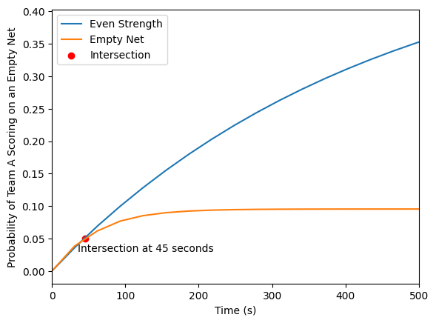

**Figure 13:** Probability of the losing team to score in the time remaining given that the losing team has shot at the net most recently.

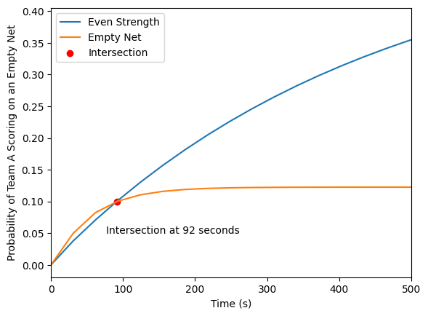

**Figure 14:** Probability of the losing team to score in the time remaining given that the losing team has shot at the net twice consecutively.

## 

**Figure 15:** Probability of the losing team to score in the time remaining given that the losing team has shot at the net thrice consecutively.

## Comparisons

Our model is better because it allows coaches to use their intuition of the state of the game to make informed decisions with statistics. While other models can predict the best time to pull a goalie, these statistics are precalculated. Our model takes in no previous values other than those that are derived from the current state of the game, and as such will be more accurate to the current game than a predetermined prediction.

Additionally, our model predicts an optimal time to pull the goalie much later in the game (less than two minutes remaining) than the other models we analyzed (154 seconds, 370 seconds, 469 seconds). This more closely reflects NHL coaches’ intuition, who often pull their goalies later in the game the models we analyzed predict.

## Bibliography

Bagozzi, R. P., & Yi, Y. (2018). On the evaluation of structural equation models. Journal of the Academy of Marketing Science, 46(3), 328-343.<https://doi.org/10.1007/s11747-017-0523-9>

Chord Analytics. (n.d.). GitHub profile. GitHub. Retrieved [insert date you accessed the profile] from<https://github.com/chord-analytics>

Donald G. Morrison, Rita D. Wheat, (1986) Misapplications Reviews: Pulling the Goalie Revisited. Interfaces 16(6):28-34.

<https://doi.org/10.1287/inte.16.6.28>

Kallio, K. P., & Kallio, T. J. (2001). An analysis of the use of global positioning system for wilderness travel. Journal of Travel Research, 40(4), 380-385.<https://doi.org/10.1080/09332480.2001.10542266>

## 

Appendix

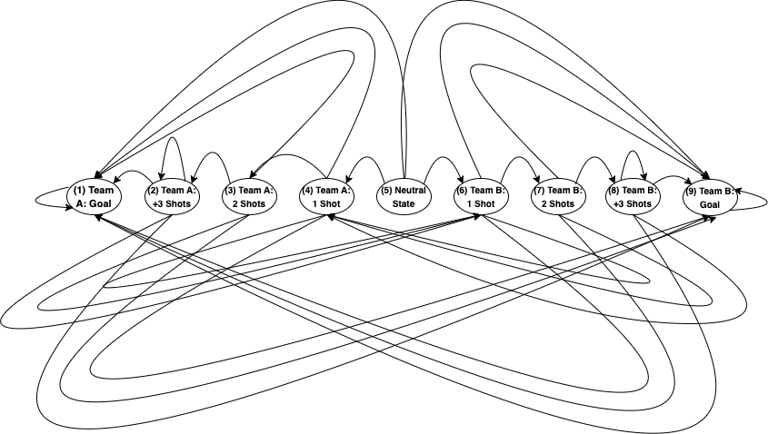

**Figure A:** Markov Chain representation of the Markov Momentum model under the *even strength* scenario.

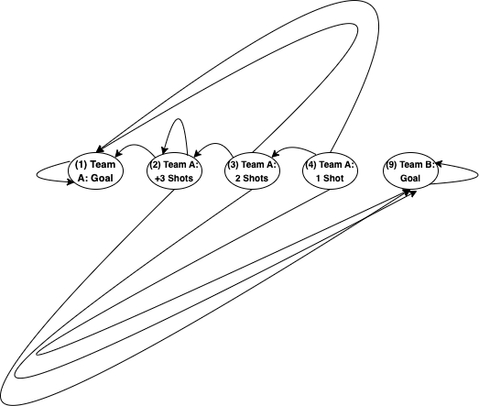

**Figure B:** Markov Chain representation of the Markov Momentum model under the *empty net* scenario.